15 June
Mainly wrestling with problems caused by getting out of gitsync.

Recent changes include
- The use of speedUpFactor as a parameter
- Mending the broken-stick function. This is now as it was originally.
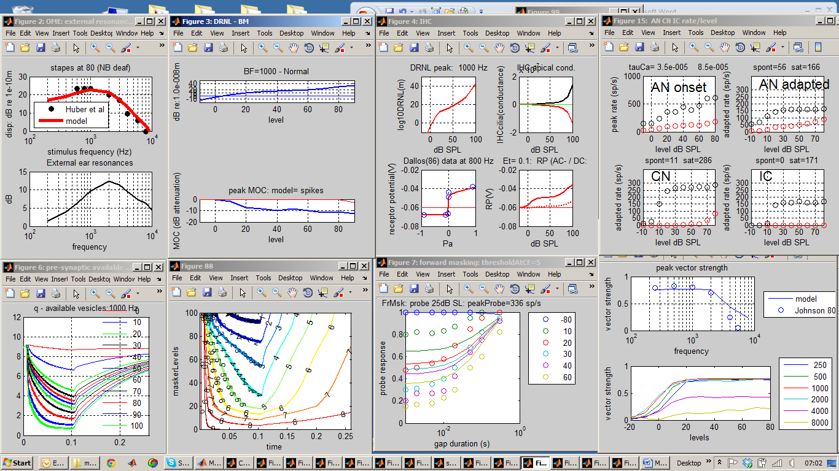
Diagnosis:
- Synapse is not flat at lowest level
- Forward masking is not strong and recovers too quickly.
- Too much phase locking at 8 kHz
Other changes
- Test_MAP simplified to remove mixer files
- showMAP options now default if missing
- showMAP is now UTIL_showMAP and stored in utilities
- UTIL_showMAP now does not show plotdivider for only one fiber type
- New userPrograms folder created
- Claim ID: 2JiVXk4jaSr430i1
- Claim Passcode: tChKEDTEhgVphqFc

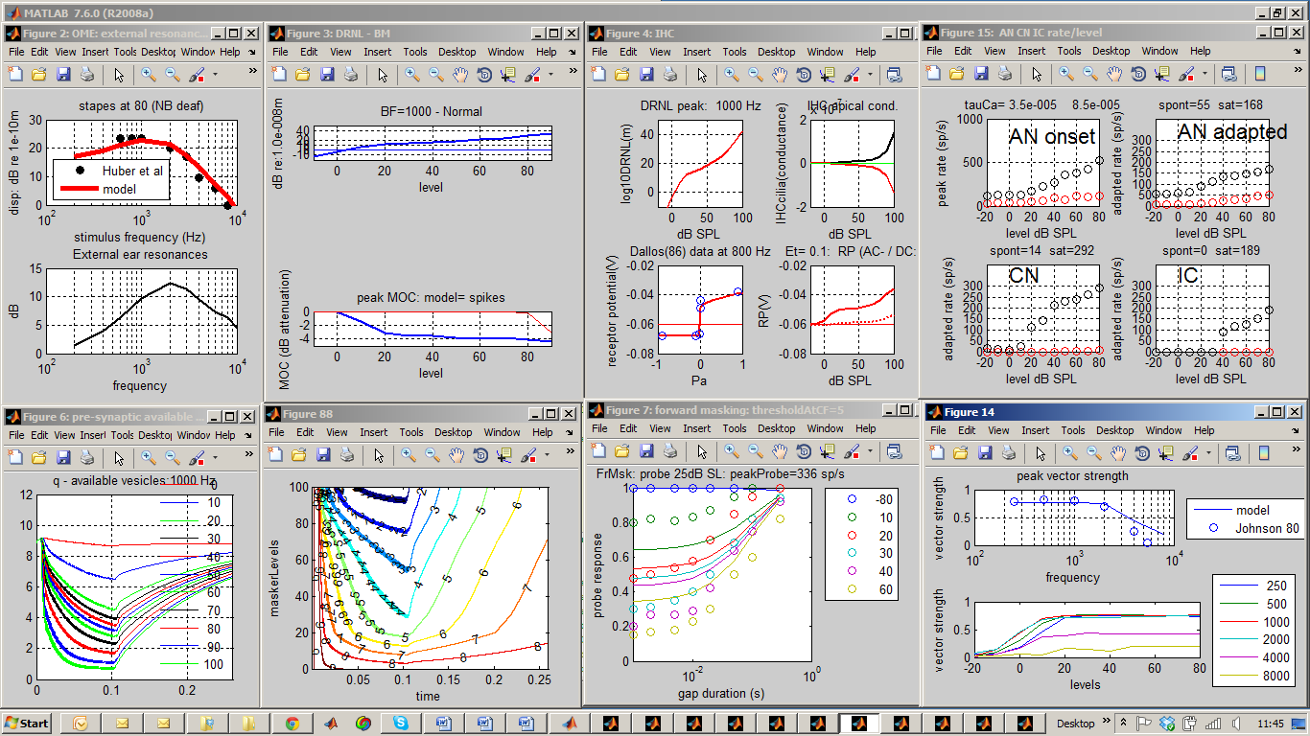
Diagnosis:
AN not saturating, too little FM, IC threshold too high,
NB phase locking estimates are the largest across all levels. This will be an overestimate in the case of 8 kHz where no phase-locking is expected; i.e. it cannot be less than zero so must be biased.

Other changes
testBM: tuning curves reduced to bottom row
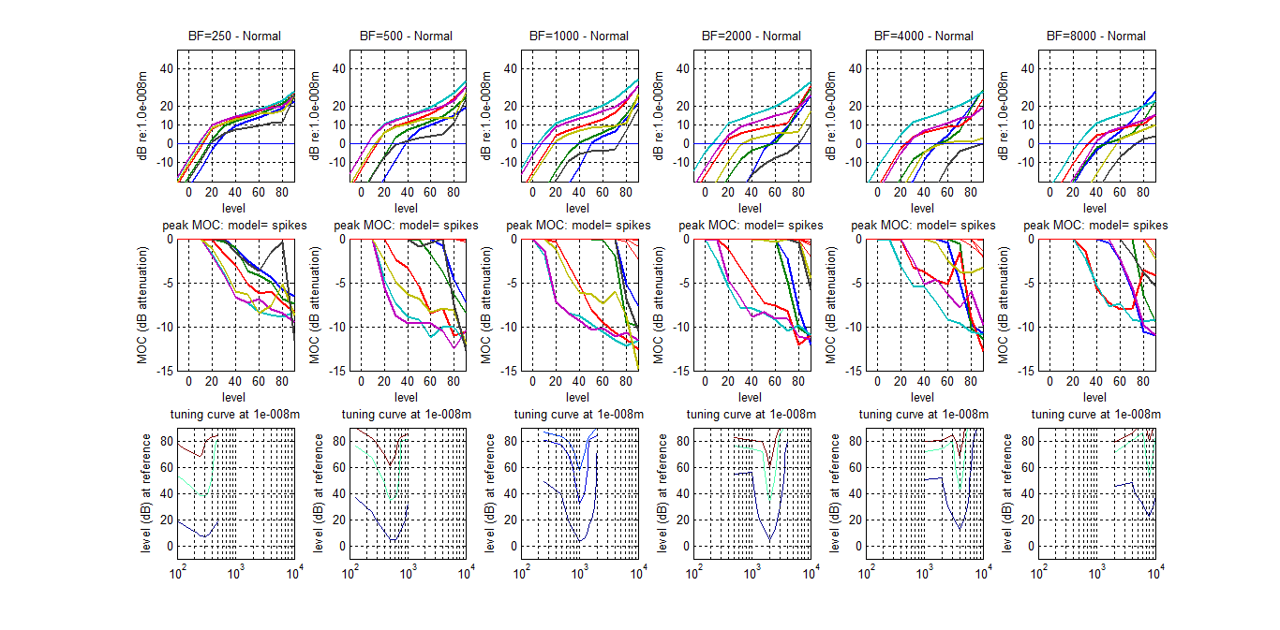
Diagnosis: at high signal levels, the filters are not as wide as they might be. Perhaps g should be greater if this is compatible with patient data.

More changes
Test_Map1_14: (PATH PROBLEMS)
Add: addpath (['..' filesep 'utilities']) to line 145
Remove: path(restorePath) from line 149
Problem:
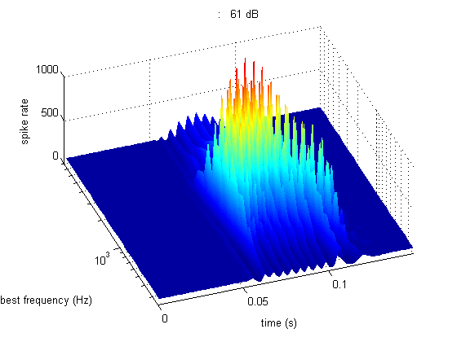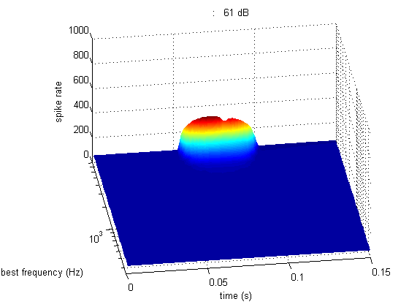
Lots of problems. Also tone should be 10 ms with 20 ms silence

June 16

Minor changes
- Path problems in test programs sorted (UTIL_showMAP).
- Improved comments in UTIL_showMAP
- Checked and working well with expGUI
- Saved as “MAP1_14f - 16 June works”
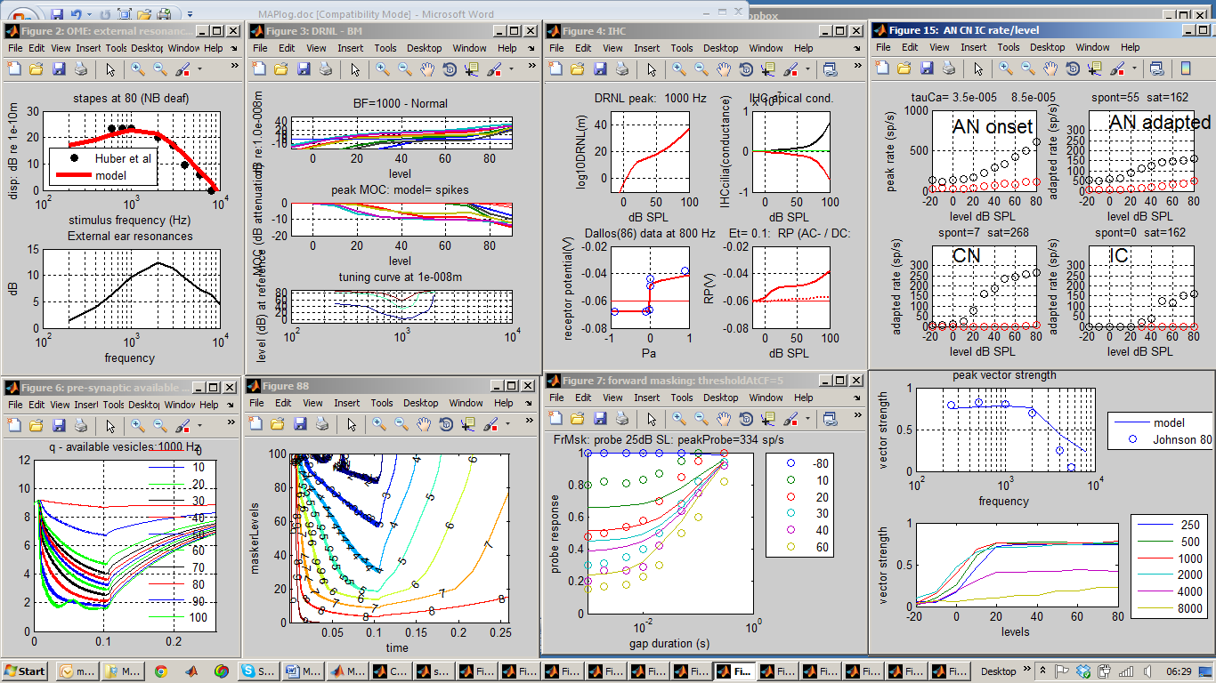

More changes
- testBM figure located
- testPhaseLocking figure located and test levels reduced to range 50-80 dB SPL
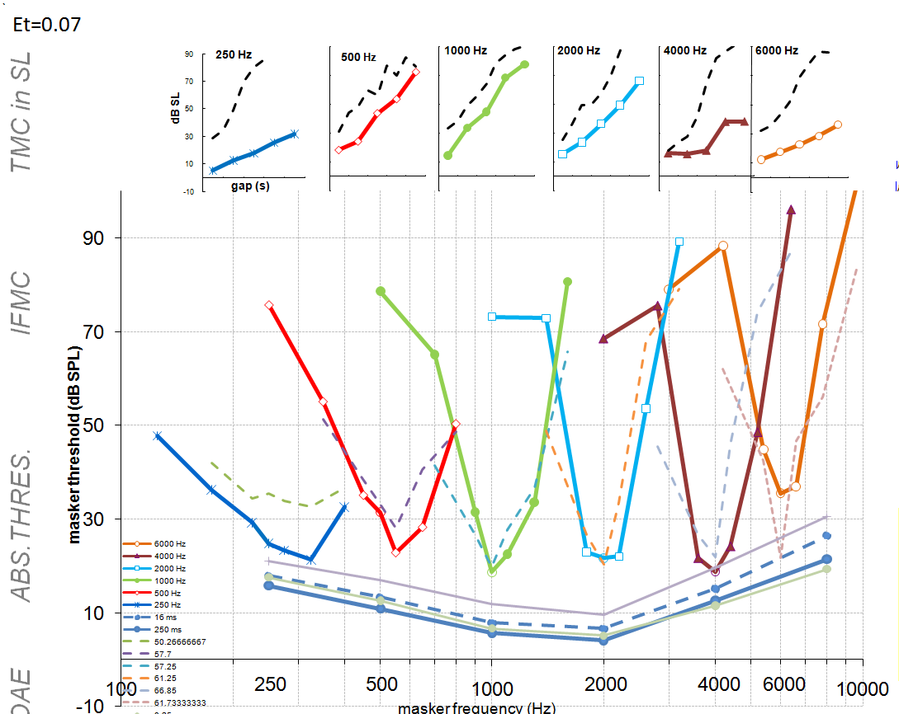
Saved as data and reports\parameter fitting\16 June 2011 profiles

